

International Technical Institute   
(01-8270)

**International Technical Institute**

# **Current ICT Infrastructure**

The current network diagram of how the network components fits together is shown as follows:

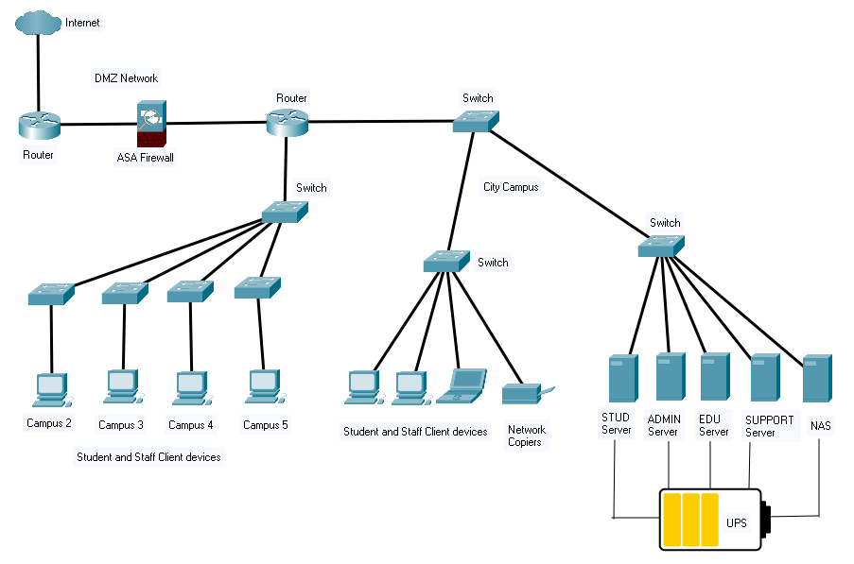

Student management is undertaken on a bespoke application called “Student Information System (SIS)”. SIS is a tool used to record student personal details, student attendance, unit results, student’s notes, and other applicable student management tasks.

International Technical Institute uses a mixture of laptops and desktop machines which all have Windows 10 and Microsoft Office 2013 installed on them. The network is managed by five servers.

* An **ADMIN server** has Windows Server 2016 installed on it and is used by the ADMIN staff of International Technical Institute. It also acts as an application server for the SIS and its associated database.
* A **STUDENT** **server** also has Windows Server 2016 installed on it and is used by the students for study purposes. It also has active directory on it, and a separate domain implementing DNS and DHCP services.
* An **EDU server** – has Windows Server 2016 installed on it and is used by the Educational staff of International Technical Institute.
* **SUPPORT server** - It includes the Active Directory, DNS, DHCP, and provides other services. It also acts as the gateway to the internet. The main function of Active Directory is to enable administrators to manage permissions and control access to network resources.
* **Network Attached Storage** (NAS) is used for accessing both staff and student files. The file server is now running out of space for storage.

A UPS is used to protect the network from power loss and electrical surges.

## Servers – Currently On-Premises

|  |  |  |  |
| --- | --- | --- | --- |
| Server | OS | Use | Quantity |
| ThinkSystem ST50 E-2104G 8GB 1xIntel Xeon E-2104G 4+2C 3.2GHz 65W | Windows Server 2016 | Administration network (isolated from education network) | 1 |
| HP ProLiant ML350 G6 Tower 12 Core CPU 2x X5650 2.67Ghz/32GB/4x300GB SAS 15K | Windows Server 2016 | Education network | 1 |
| Hp ProLiant ML350p Gen8 Xeon E5-2620 CPU @2.0Ghz 6 cores 32GB Ram 6.6TB SAS (A1) | Windows Server 2016 | STUDENT server | 1 |
| HP ProLiant ML350 G6 Tower 12 Core CPU 2x X5650 2.67Ghz/32GB/4x300GB SAS 15K ThinkSystem ST50 E-2104G 8GB **ThinkSystem ST50 E-2104G 8GB****ThinkSystem ST50 E-2104G 8GB****ThinkSystem ST50 E-2104G 8GB** | Windows Server 2016 | SUPPORT server | 1 |
| PowerEdge T440 Tower Server  Intel Xeon Bronze 3204 1.9G, 6C/6T, 9.6GT/s, 8.25M Cache, No Turbo, No HT (85W) DDR4-2133 | Windows Server 2016 | NAS | 1 |

## Classrooms

23 Classrooms – each with 20 PCs (HP Elite 8200 Desktop PC Core i5 - 2400 PC 8GB Ram 250GB HDD Win 10 Pro)

## Staff Computers

Each staff member has a Laptop - Lenovo ThinkPad T490 14" Laptop i5-8265U 8GB 256GB SSD W10P

## Users on the network

* Approx. 250 students
* Approx. 70 staff